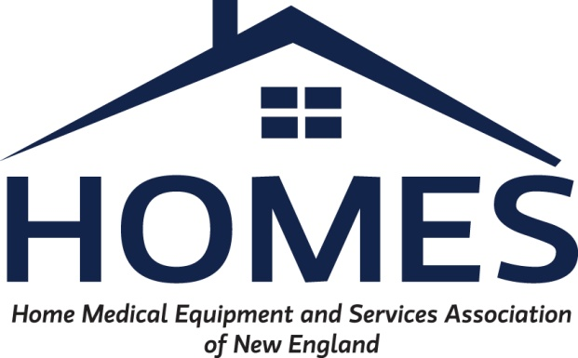

NH DHHS / HOMES Meeting Agenda:
November 5, 2021 at 11:00 AM
Attendees:

…pending

Ongoing Items:

- Non-Sterile Glove & Labor Code (K0739) Reimbursement: A4927
a, Clarification of effective date on the rate change for Gloves A4927.

Effective date stated of 1/1/2022 to have in place, what is the retroactive date?

b. Rate for Non-Sterile Gloves by MCOs

Our understanding is that the rate is $10.12, but we need to ensure that the MCOs – specifically NHHF and Amerihealth – will be mandated to pay 100% of that rate. If not, we will be below our cost of product and will need to discuss further. Wellsense is currently paying providers $11.00/box.

c. Status of Labor Code K0739.

Please update where this code is in process for evaluation for rate increase.

- Milk Storage Bag (K1005) pricing / policy:

We appreciate the rate of $0.24/bag for reimbursement as of 10/1/2021. However, as with gloves above, we need to discuss MCO reimbursement for these bags, as the rate will not be sufficient at 80% of the rate. Jason Canzano can provide additional information regarding the MCO reimbursement as it relates to milk storage bags.

- E0604 - Hospital grade Breast Pump: Discussion regarding current reimbursement

Please provide update as to status of research, which was pending as of 10/8/2021.

- Capped Rental Methodology:
- DHHS had previously reviewed information submitted by HOMES and identified a list of potential codes for consideration. This list was forwarded to HOMES on 5/6/2021 for review. Additional discussion / clarification on the code list may be needed. Should we consider a follow up meeting for the Capped Rental Sub-Committee?

Jason Morin and Tamme Dustin met with the sub-committee from DHHS on Friday, September 24^{th.} Information was provided to group by HOMES would like an update on rent-to-own process and any fiscal or systems impacts if anything else is needed from HOMES at this time to continue review.

- Manually Priced Codes to consider fee schedule adoption: Suggest considering the following codes for adoption of rate at 100% Medicare fee schedule. Codes are currently Manually Priced on the Covered Code Fee Schedule.
HCPC code | Medicare | NH DHHS
E1006 | $6,476.90 | MP
E1007 | $8,770.30 | MP
E1002 | $6,477.90 | MP
E1028 | $207.10 | MP

Jayne stated that she agreed with the strategy of reviewing a small number of claims. Sheri will add these codes to the worklist for pricing analysis. Sheri will also attempt to pull utilization on codes that are currently manually priced on the Covered Fee Schedule. HOMES group will begin reviewing g additional codes based on utilization / impact.

As of 10/8/2021, the manually priced codes review is an ongoing process. These codes are currently manually priced.

Please provide an update.

- For additional funding CFI Program: DME integrated to HCBS to be included

- Procurement & Supply Chain Discussion: The pandemics impact on the procurement process for Home Medical Equipment (HME) has been devastating. Current predictions estimate that the increased costs and other effects will last far beyond the end of the Public Health Emergency (PHE). As an industry whose reimbursement does not compensate for these fluctuations many providers are struggling to continue to be able to provide required services to beneficiaries.

Positive discussion was held regarding the impact of the pandemic on the HME supply chain. HOMES members illustrated the various ways that costs have been risen dramatically.

HOMES is working on compiling more detailed information for the state and other payers to highlight the impact to providers. Due to the transition of President/CEO of HOMES, we do not have the detailed provider information at this time. However, we are attaching several documents to support the previous discussion.

Please update us with any information needed.

- American Rescue Plan: HOMES members would like to discuss the states plan for utilization of the increased FMAP and any feedback on HOMES proposal of suggested areas relative to HME. Copy of HOMES proposal attached.
  - MA issued emergency adoption of new rates 7/19/2021 https://www.mass.gov/regulations/101-CMR-44700-rates-for-certain-home-and-community-based-services-related-to-section-9817-of-the-american-rescue-plan-act

Meeting was held 10/27/2021 and included HOMES president. Discussion surrounded adding labor code for Respiratory Therapist visits in the home. HOMES noted that many other services are provided in the home in addition to respiratory therapist services, such as delivery, setup, pickup, item exchange, provision of additional portable oxygen, repairs and/or replacement, 24-hour on call, education and training of patients and/or family members. These additional services transcend all products provided by DME/HME companies.

Please update providers with any additional information since the 10/27/2021 meeting.

New Items:

- Update on Peristeen (Coloplast) research for codes and fiscal impact. Clients are pending with some providers and Dartmouth Hitchcock MC pending resolution.

- Compression garments and Quantity Allotments per Fee Schedule –
  - Compression garments usually limited to 2/year of the same item.
  - Compression garments need to be washed regularly, and patient should have additional garments on hand to continue use while drying.
  - These garments, while relatively durable, generally can wear out prior to the end of a year, should a patient receive two garments initially.

Please consider increasing utilization limits on these items, particularly A6549.

