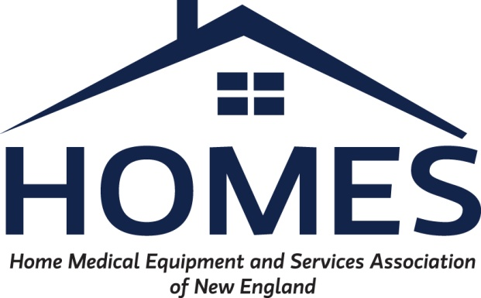

NH DHHS / HOMES Meeting Agenda:
July 29th 2021 11:00 AM

Ongoing Items:

- Non-Sterile Glove & Labor Code (K0739) Reimbursement:
- Currently under review by DHHS

- Milk Storage Bag (K1005) pricing / policy:
- Currently under review by DHHS, additional information regarding utilization was provided by Jason Canzano after previous meeting on 5/6/2021.

- Capped Rental Methodology:
- DHHS had previously reviewed information submitted by HOMES and identified a list of potential codes for consideration. This list was forwarded to HOMES on 5/6/2021 for review. Additional discussion / clarification on the code list may be needed. Should we consider a follow up meeting for the Capped Rental Sub-Committee?

- HCPC Code A6549
- DHHS has reinstated this code retro to 7/1/2018 and notified each of the MCO’s. Affected providers should have been notified and given a process to correct.

Any further discussion required on this item?

- Manually Priced Codes to consider fee schedule adoption: Suggest considering the following codes for adoption of rate at 100% Medicare fee schedule. Codes are currently Manually Priced on the Covered Code Fee Schedule.
HCPC code | Medicare | NH DHHS
E1006 | $6,476.90 | MP
E1007 | $8,770.30 | MP
E1002 | $6,477.90 | MP
E1028 | $207.10 | MP

New Items:
- Procurement & Supply Chain Discussion: The pandemics impact on the procurement process for Home Medical Equipment (HME) has been devastating. Current predictions estimate that the increased costs and other effects will last far beyond the end of the Public Health Emergency (PHE). As an industry whose reimbursement does not compensate for these fluctuations many providers are struggling to continue to be able to provide required services to beneficiaries.

- Phillips Respironics recall of ventilator & positive airway pressure devices: On June 14th, 2021, Philips Respironics issued a voluntary recall for a number of ventilator and positive airway pressure devices. This recall has had a major impact on the respiratory community. HOMES would like to update the state on the current status of the recall and projected long-term impacts.

Attachments:
- Philips recall letter
- Clinical community Joint Letter
- Recommendations for Sleep and Critical Care Medicine Professionals Regarding Philips Recall
Notice
- AA Homecare Philip Recall Letter

- American Rescue Plan: HOMES members would like to discuss the states plan for utilization of the increased FMAP and any feedback on HOMES proposal of suggested areas relative to HME. Copy of HOMES proposal attached.
  - MA issued emergency adoption of new rates 7/19/2021 https://www.mass.gov/regulations/101-CMR-44700-rates-for-certain-home-and-community-based-services-related-to-section-9817-of-the-american-rescue-plan-act

- E0604 - Hospital grade Breast Pump: Discussion regarding current reimbursement

